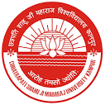
CHHATRAPATI SHAHU JI MAHARAJ UNIVERSITY
(Formerly Kanpur University, Kanpur)
Kanpur UP – 208024

A

Student Satisfaction Survey (SSS) on overall institutional performance
2020 – 21

Under Caption 2.7.1
In

Criteria – II
Teaching, Learning & Evaluation
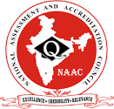

for
The Fulfilment

of
Annual Quality Assurance Report (AQAR)
2020 – 21

National Assessment and Accreditation Council
(NAAC)

Questions/Item-wise Analysis Report

Que-1 How much of the syllabus was covered in the class?

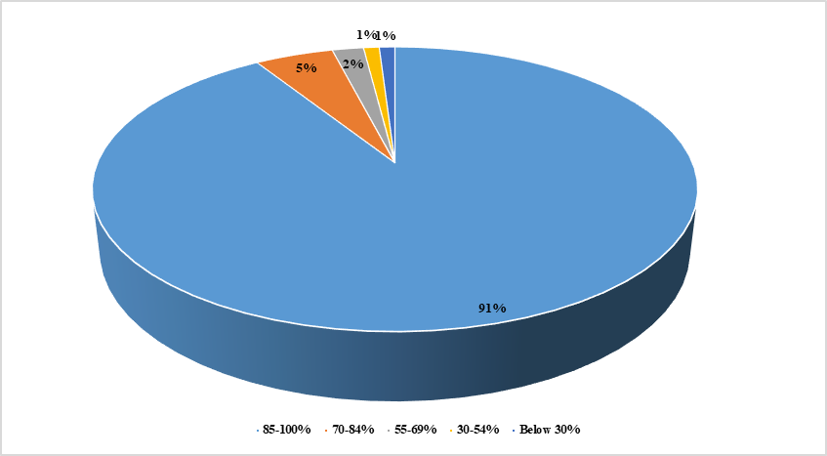

Que-2 How well did the teachers prepare for the classes?

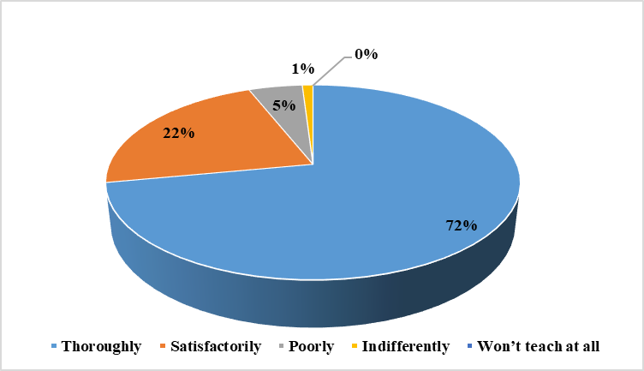

Que-3 How well were the teachers able to communicate?

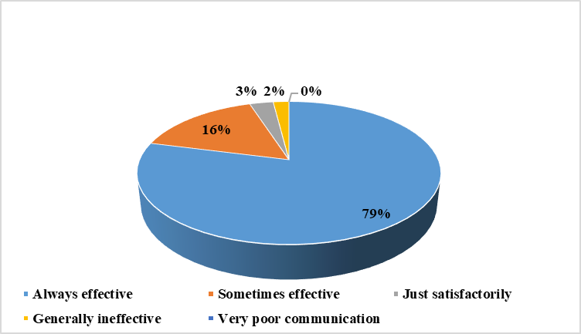

Que-4 The teacher’s approach to teaching can best be described as?

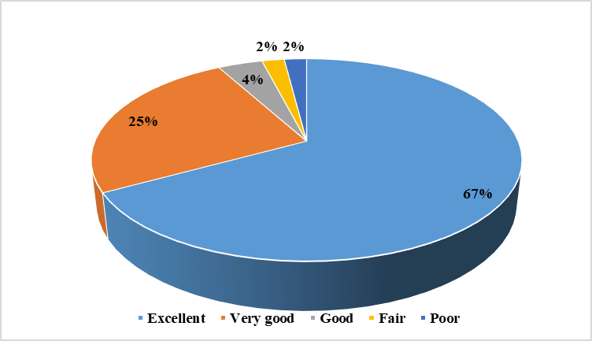

Que-5 Fairness of the evaluation process by the teachers?

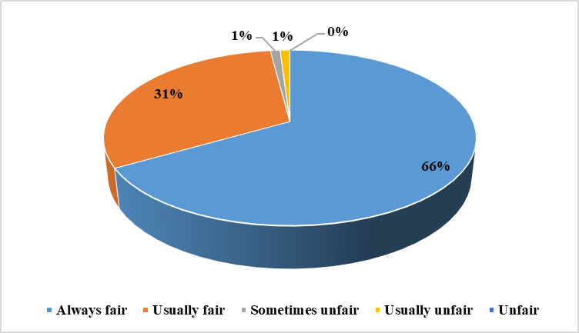

Que-6 Was your performance in assignments discussed with you?

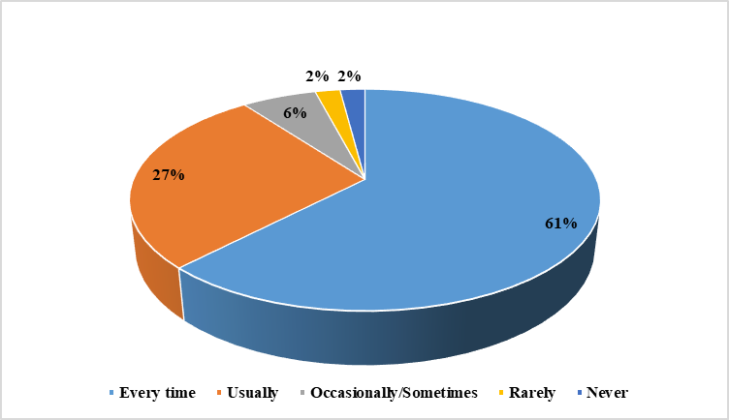

Que- 7 The institute takes active interest in promoting internship, student exchange, field visit opportunities for students.

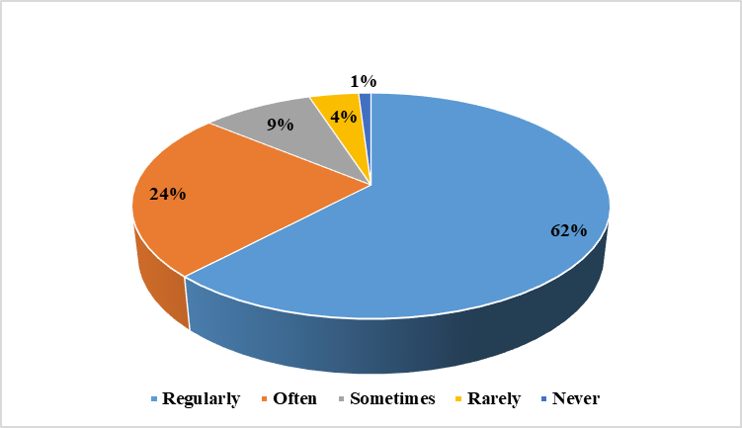

Que-8 The teaching and mentoring process in your institution facilitates you in cognitive, social and emotional growth?

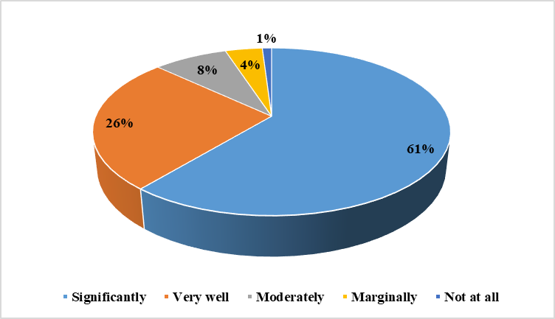

Que-9 The institution provides multiple opportunities to learn and grow?

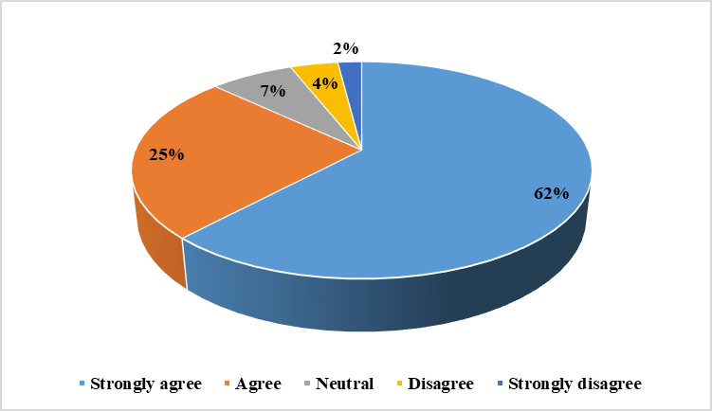

Que-10 Teachers inform you about your expected competencies, course outcomes and programme outcomes.

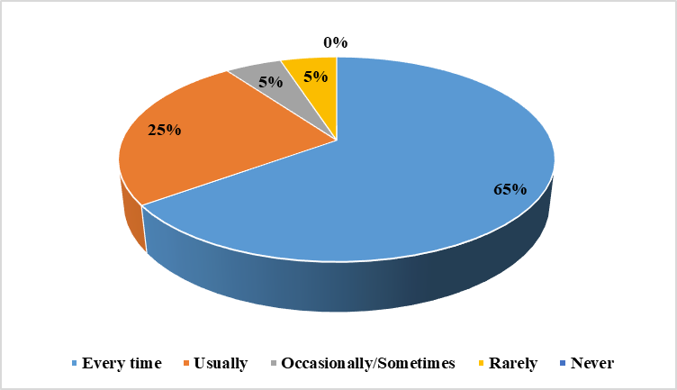

Que-11 The teachers illustrate the concepts through examples and applications.

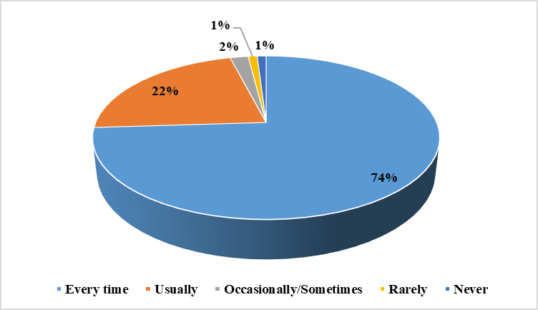

Que-12 Teachers encourage you to give suggestions to improve teaching learning process.

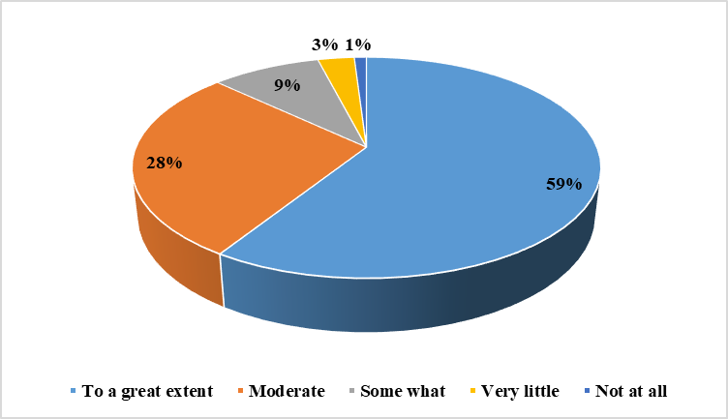

Que-13 What percentage of teachers use ICT tools such as LCD projector, Multimedia, etc. while teaching?

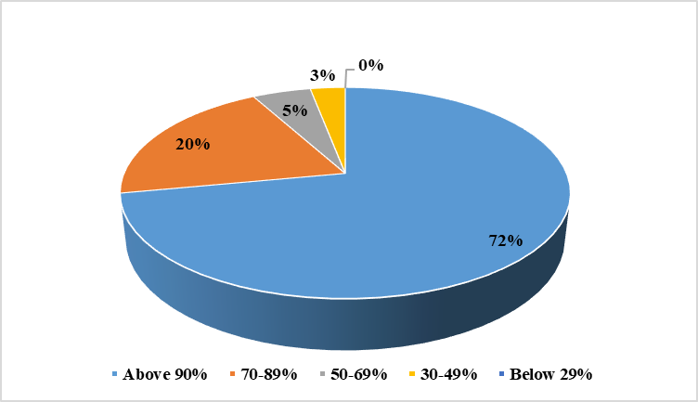

Que-14 The overall quality of teaching-learning process in tour institute is very good?
